PROVISIONAL MARKING KEY
BIOLOGY II

Take two petri-dishes and tightly pack them with wet cotton wool ¹, and label the dishes A and B ¹.

Pin 2 - 3 pre-germinated bean seedlings on the cotton wool parallel to each
other, making sure that there is space between the seedlings ¹.

Make the petri-dishes stand on a bench and lean them against a wall, such that
in dish A, the seedlings are in horizontal position ¹. In dish B, the seedlings are
in vertical position in a way that plumule points upwards and radicle points
downwards ¹. Leave the set-ups undisturbed and observe the results after
about2 days ^{1.} In petri-dish A, the plumule could grow bending upwards while
the radicle grew bending downwards ¹.

From the results, plumule or shoot grows away from the gravitational pull or
force, showing negative geotropism ¹, whereas radicle or root grows towards
the gravitational pull or force, showing positive geotropism ¹.
- Therefore, radicle responds to stimulus of gravity in seedlings ¹.

Collect green leaves from a plant ¹.Crush the leaves using a mortar and a pestle ¹.
Put the crushed pieces of leaves into a small glass beaker ¹ and add a little ethanol.
Heat the small glass beaker containing the crushed leaves in a water bath/ until the alcohol turns green.
Filter the green liquid into a clean beaker ¹.
Cut a rectangular piece of filter paper¹ measuring 5cm by 1.5 cm.
Stick it unto a glass rod using cello tape for support ¹.
Suspend the filter paper into a beaker containing the green liquid such that its tip touches the green liquid ¹.
Wait for some time ¹ so that the filter paper absorbs the green extract.

Expectedly, as the green liquid rises along the filter paper by capillary action different shades of colours will be observed on the filter paper ¹.

This shows that fresh green leaves contain different types of pigments ¹.

- a. 1mark for any length between 40mm and 60mm

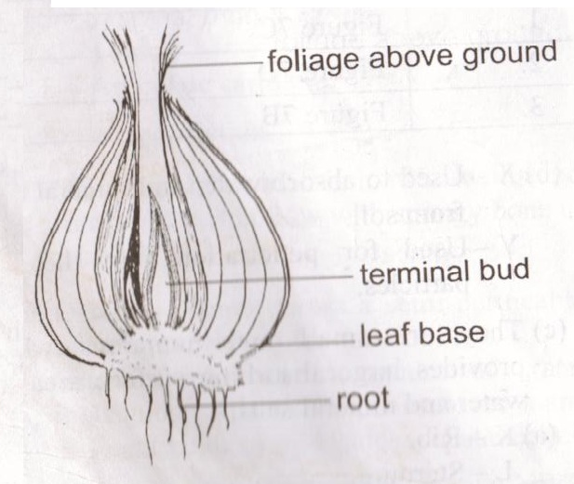

b. 1 mark for correct diagram
2 marks for any two correct labels
3c. – vitamin
--carbohydrates
-mineral salts (iron, magnesium) 2 marks for any 2

3d. Crush specimen N using a mortar and a pestle.
Add a little distilled water to the crushed particles and filter it to get the extract of specimen N.
Put the extract of specimen N in a boiling tube and add an equal amount of Benedict’s solution.
Heat the mixture for some time. If the colour of Benedict’s solution changes from blue to brick red it confirms presence of reducing sugars

4 a (i). Dicotyledonous (1mark)
(ii). It has a net vein or reticulate venation (1mark)
b. M: Mesophyte (1mark)
P: Xerophyte. (1mark)
c. Has a thick cuticle/ to reduce excessive loss of water thorough transpiration
Has a succulent tissue / for storing water
Any 2 X 2
d. ropes (1mark)
Door mats (1mark)

